THE ABC’S OF FREE STANDING LACE
Free standing lace vs. Standard lace designs
Standard Designs or Lace blown up
A digitizers goal with when creating designs is to use with as few stitches as possible and create a beautiful product . Thick, heavy stitch designs that are body armory will not yield a pleasant result, and are ‘old school’
“Regular or standard lace designs” are embroidered on stabilizer AND fabric. The needle penetrations through and catching of the fabric fibers is what holds the design together and supports the design.
There are no interlocking stitches that hold the design together. If you remove the fabric OR sew the design without fabric, the design will fall apart—literally.

An example of lace falling apart:
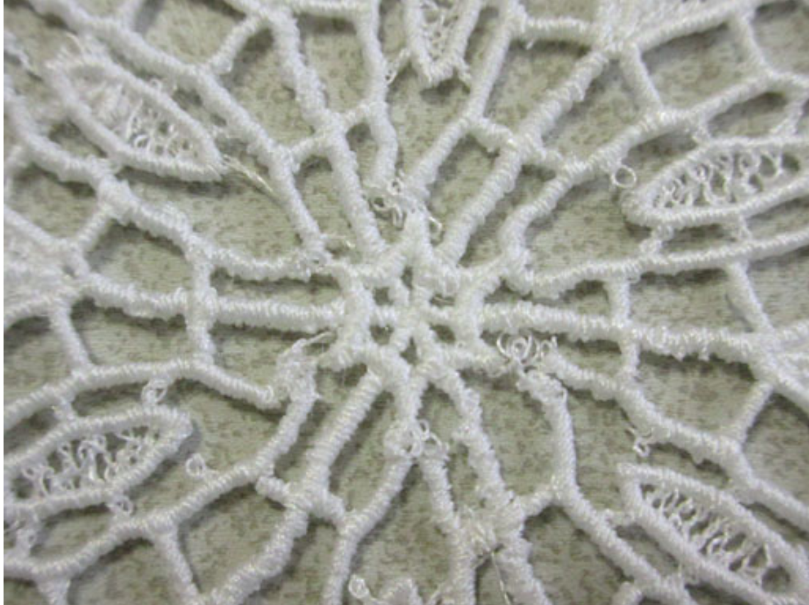

What is Free Standing Lace?
- Freestanding lace (FSL) are specifically digitized designs that are sewn out on a water soluble stabilizer such as Matilda’s Lace Base.
- FSL designs have much higher density stitch blocks, or in English, a much, much higher stitch count when compared to non-lace embroidery designs.
- Why do the designs stay together?? The stitches of FSL are interlocking to help hold the entire design together. This combined with the stitch intensity is what holds it together
- When finished sewing the design out, the design is rinsed with warm water and Matilda’s Lace Base dissolves away, leaving only the lace.
- Only designs digitized for freestanding lace designs will be stable after the stabilizer is washed away, other designs will fall apart. LITERALLY
- Free standing lace may be used as an embellishment on fabric but a non FSL design may not be used as Free Standing Lace
TIPS FOR GREAT RESULTS:
- Only use designs that say “FSL or free standing lace”
- DO NOT RESIZE THE FSL DESIGN. More than likely it will fall apart as the stitches will not interlock.
- Proper tensions are necessary for both upper and lower thread, to get a well balanced design.
- Make sure your needle is fairly new. The design will be dense and a dull needle will cause problems.
- Only uses a high quality thread:
  - Thread breaks and bird nesting will show.
  - Skipped stitches will also show.
    - Both of above will occur with low quality thread.
- Do not let your thread tails get over sewn into the design.
- Hooping and stabilizing is CRITICAL.
  - Hooping
    - Use the smallest size hoop possible
    - ONLY PUT ONE DESIGN IN THE HOOP!
      - Dissolvable stabilizer does not have fiber in it. It will stretch in the hoop with multiple needle penetrations. Free standing lace is stitch intensive and has many needle penetrations. The result of putting multiple designs in the hoops will most likely be off register and fall apart if you
  - Stabilizer
    - Use of proper Stabilizer is ultra important.
    - As a general use plan on two layers of dissolvable lace. If the design is over 50K stitches you MUST use 2 layers of Lace Base.

- For a finer lace use bobbin thread or Matilda’s Fine Line thread in bobbin and upper thread.
- Doilies, bowls and decorative items use a 40# weight such as Matilda’s Polyester Embroidery thread
- When doing an item where the reverse side will show, use top and bottom thread the same. It looks more professional. Yes, sometimes you must wind multiple color bobbins, get over it!

- Once the design is finished sewing, trim as much of the Lace Base as possible away.
STOP AT THIS POINT!!!! Before you put the lace in water. LOOK IT OVER CAREFULLY. Use a magnifier if possible. Look for problems

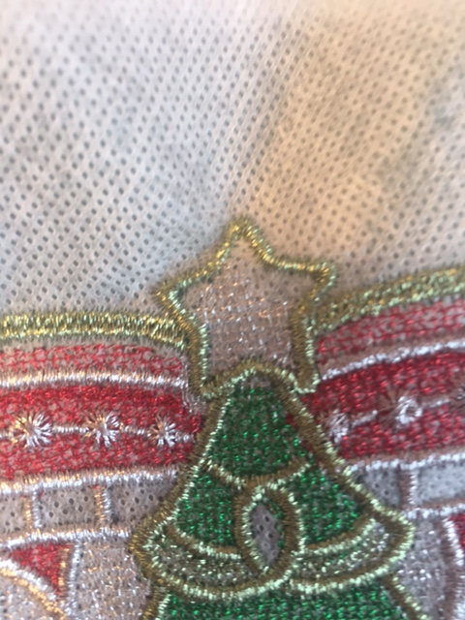

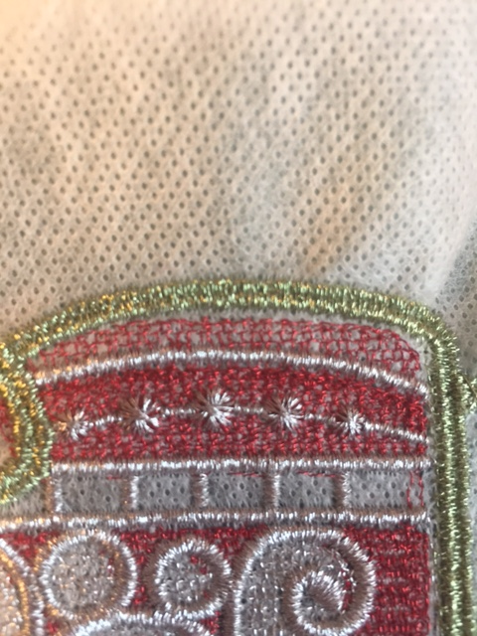

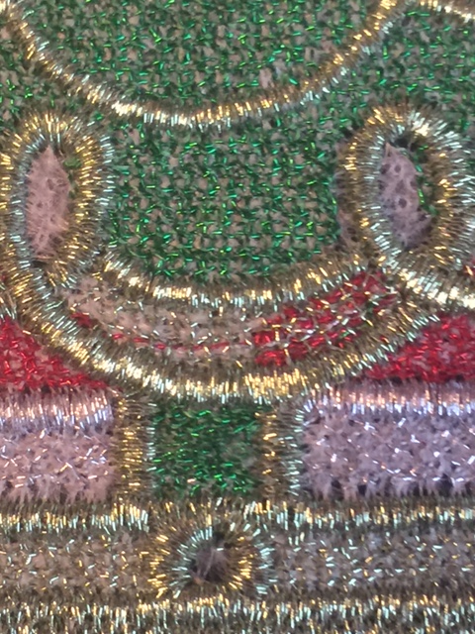

- Soak the item in a bucket of hot or warm water. (Luke warm if using Rayon thread. It will shrink)
  - If you want the design to have body, do not leave in the water long. Only long enough to remove the visible stabilizer. The longer in the water the more the stabilizer is removed and the softer and less body on the lace.
  - The lace item may be sticky, but that will go away as the item dries.
  - Blot away excess water between sheets of paper towels. Be careful the towel does not stick to the lace
  - Shape item if necessary and allow to dry. Good old fashioned wax paper works great.
  - A warm hairdryer will speed the drying process.
  - Keep the hairdryer moving if on wax paper or you may stitch the item to it.

